## Q1

The main and significant difference between isolated and non-isolated channel oscilloscope is the connection of negative terminals. While isolated channel oscilloscopes allow connecting negative terminals of channels separately, the negative terminals of non-isolated channels share the same negative terminal. Hence, the safety should be considered according to the isolation of channels.

## Q2

Diode is simply a p-n junction device. While a p-side (*Acceptors*) includes holes, a n-side (d*onors*) includes electrons. When the junction is provided between the n-side and the p-side, holes diffuses to the n-side and electrons diffuses to the p-side. Hence, “*diffusing carriers leave behind the charge of the immobile ionized impurity atoms (donors in the n-side and acceptors in the p-side). The uncompensated charge creates a built-in E-field at the junction*”. [1]

The region in which built-in E-field occurs is named as a depletion region. The built-in E-field creates a voltage difference across the depletion region. The voltage difference restricts the diffusion of carriers through the depletion region according to the magnitude of the voltage difference. The effect of biasing on voltage difference across the depletion region can be seen in Figure 1.

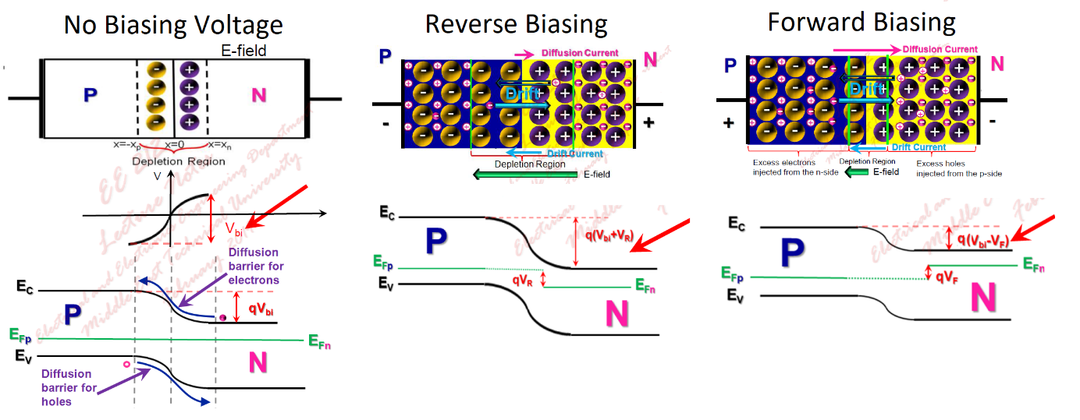

Figure 1 The effects of biasing voltage on voltage difference accross the depletion region and diffusion of carriers

The diffusion current is in the same direction as the forward current. The forward biasing decreases barrier voltage across the depletion region, so that the rate of diffusion increases. As a result, the forward voltage is required to generate the desired amount of forward current, which is the explanation of why a forward voltage is observed between the terminals of a diode.

Two parameters affect the value of forward voltage; a value of forward current and temperature.

The effect of forward current has been explained above; as the forward current increases, the forward voltage increases.

The thermal generation rate depends on the temperature in semiconductor devices. The carrier concentration increases with temperature. The supplied forward current at high temperature is higher than the supplied current at low temperature for the same value of forward voltage. Hence, an increase in temperature decreases the forward voltage. Also, the voltage difference across the depletion region can be calculated in Equation (1) .

|  |  |  |
| --- | --- | --- |
|  |  | (1) |

## Q3

When the peak of the input voltage has increased from 325V to 500V, the peak of the forward voltage has reached up from 1.8V to 2V due to the increase in the peak of the forward current. The forward voltage relation with the current has been examined in Q2.

## Q4

The loss components of a diode can be classified with 3 main loss mechanism;

* Conduction losses
  + The product of forward voltage and forward voltage drop on diode generates a loss. Conduction loss becomes dominant at low frequencies.
  + Conduction losses can be diminished with a decrease in forward voltage.
  + Conduction losses at 500V are higher due to an increase in both forward voltage and current.
* Switching losses
  + The transients during switching and recovery charge result in switching loss.
  + Switching losses increases with switching time, frequency, and recovery charge.
  + The switching losses are relatively small for the simulated half-wave rectifier due to low frequency.
* Reverse current loss
  + The product of reverse current and reverse voltage generates loss.
  + It can be neglected generally. However, when the temperature increases, the reverse current increases much. Hence, reverse current loss can be considered for high temperature conditions.
  + The reverse current losses are relatively small for the simulated half wave rectifier.